Simulator License active SOP

- Set Twincat to config
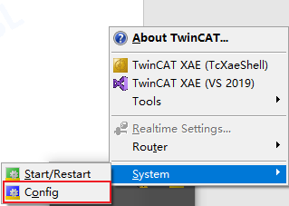
- Click ” TwinCAT XAE（VS 2015）”
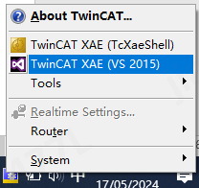
- Click FileNewProject...，choose TwinCAT ProjectTwinCAT XAE Project（XML format）
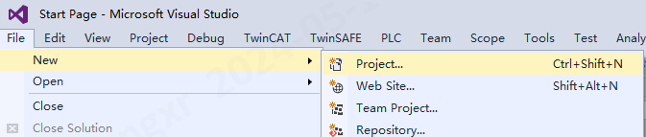
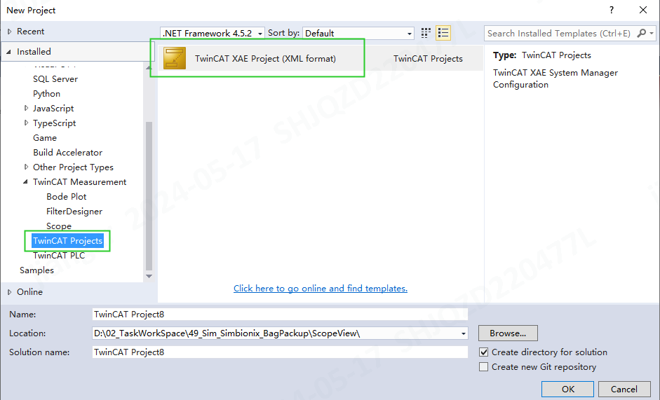
- Find “License” in solution, then Choose “Add”
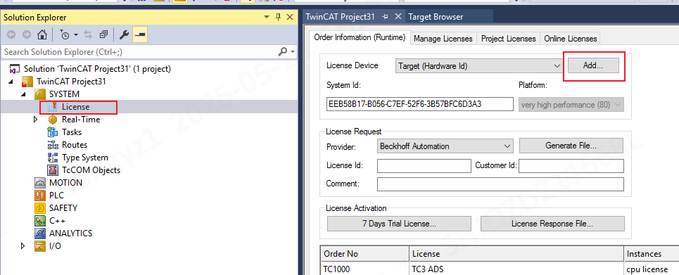
- Choose “Search USB Dongle on Target” and Select USB Dongle -> choose “ok”
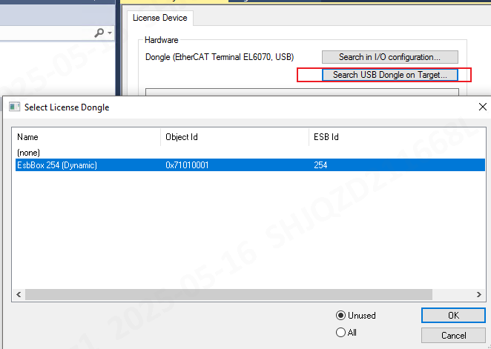
- Click”Cache Dongle Licenses” and choose ”update license…”
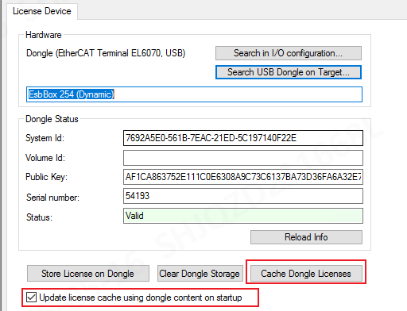
- SystemStart/Restart。
